

**Sri Lanka Institute of Information Technology**

**Group Assignment**

Software Engineering Process & Quality Management (SE 3010)

Year 03 Semester 01 – 2017

Group ID : 03 (WE Batch)

Submitted by:

1. IT 14098888 - S.C.G. Liyanage
2. IT 14084614 - D.A. Polwattage
3. IT 14104640 - S.R. Rajapakse
4. IT 15068774 - A.P.I.R. Jayathilaka

Submitted to:

…………………………..

Mr. Indraka Udayakumara / Mr. Saman Gunawardena

20-05-2017

**Static Code Analysis - Kiuwan**

**Introduction to tool**: - Kiuwan is a static code analysis tool for code quality management which is offered as software as a service (SaaS) product. [1]

**Download and configuration details: -** Need to visit: - [2]

Basically, two download options

1. Free trial: - If it is for non-business purpose, have to go with the Github free repo which can be used as a free open source software. For scanning our code base, it should be in the same Github account.
2. Local analyser

**Usage of Tool: -** [3]

* CIOs need this to make strategic decisions to improve software development.
* ForQA managersand engineers who need actual state of applications under development.
* CSOs to tackle security from the application perspective.
* Project managers can know the health of the projects from a technical perspective.
* Application architects can discover structural flaws early in the development process.
* Developers want this to develop the best software possible and learn as much as possible in the process.

**Strengths:-**

* It has the right information to the right stakeholder in the IT department.[3]
* Supports for all major programming languages like Java, C/C++, JavaScript, PHP, C#, .NET, VB, Objective-C, Cobol, SQL, etc. [1]

**Weaknesses:-**

* When using the Github as an open source Kiuwan, it can analyse only the repositories which are in the same Kiuwan Github account.

**User Reviews of the tool**: - [4]

*“Integration with Jenkins and JIRA, And The Security Support, Are Valuable.” -* [Jorge Para Molina](https://www.itcentralstation.com/users/jorge-para-molina)

**Snapshots of tool usage using selected code samples:-**

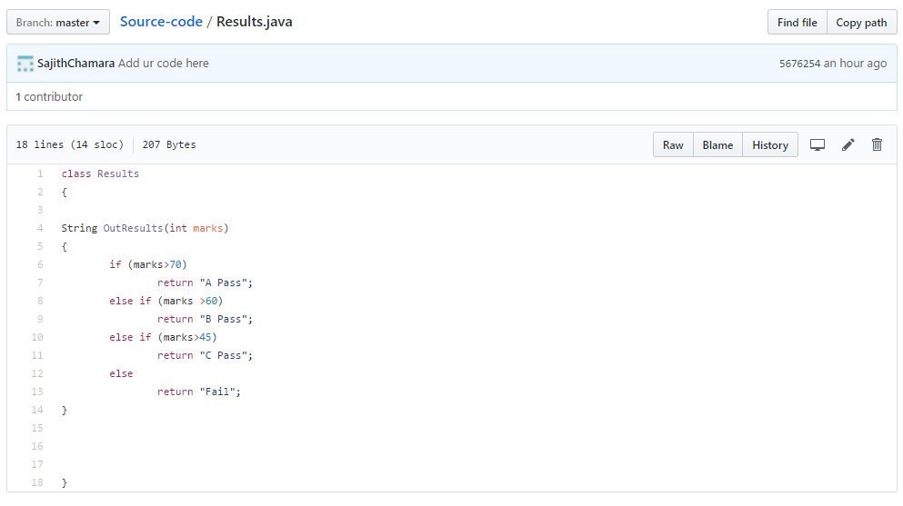

Figure 1:- Results.java in Github

**Outcome of the tool:-**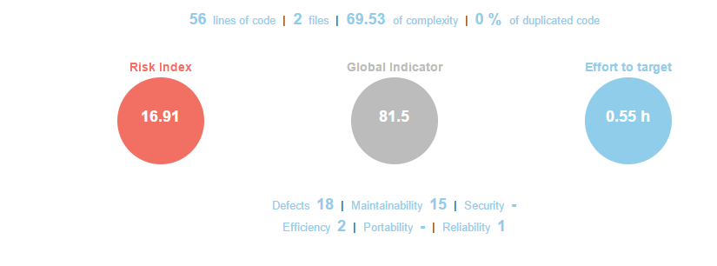

Figure 2:- Kiuwan report

**Structural Code Coverage – Jacoco**

**Introduction to tool: -** Jacoco is a structural code coverage tool to generate a report for how much percentage of java code is covered by implemented test methods.

**Download and configuration details:-**

Download from [5] or mention the URL in the root pom.xml to download through internet. Build the java project with test classes, using maven or ant. Then render the index.html page which is in the <YourProjectName>\target\site\jacoco to see the generated report.

**Usage of Tool:-**Developers are massively used in maven projects to see the code coverage level.

**Strengths: -** Easy to use and view a clear report.

**Weaknesses: -** Up to now only supported to java projects which built using maven or ant.

**User Reviews of the tool: -** [6]

**Snapshots of tool usage using selected code samples:-**

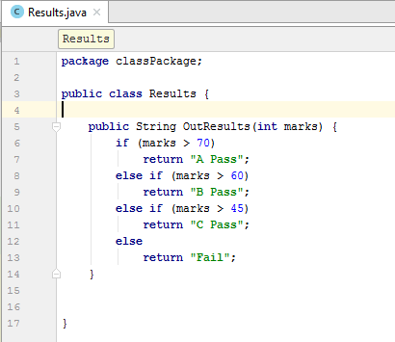

Figure 1:- Results.java

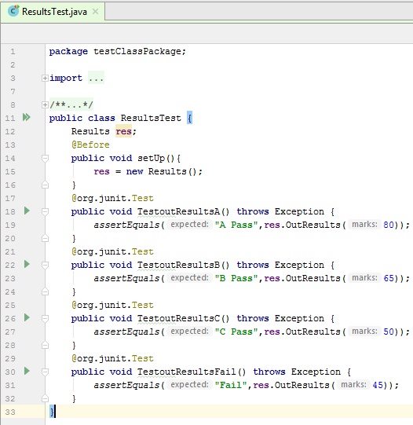

Figure 2:- ResultsTest.java

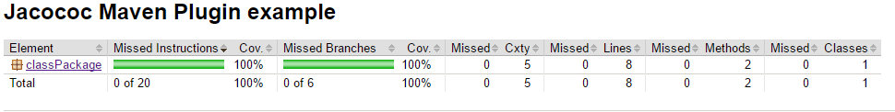**Outcome of the tool:-**

Figure 3:- JaCoCo Report

**References**

[1]"Technical Debt Computation: Comparison Of Top Tools". *Build Blog by ThinkApps | Content on Entrepreneurship, Mobile Apps, Web Platforms and more*. N.p., 2017. Web. 20 May 2017.

[2]"Software Analytics Platform - Kiuwan". *Kiuwan*. N.p., 2017. Web. 20 May 2017.

[3]"Who Is It For? - Kiuwan - Kiuwan Documentation". *Kiuwan.com*. N.p., 2017. Web. 20 May 2017.

[4] "Product Review For Kiuwan". Itcentralstation.com. N.p., 2017. Web. 20 May 2017.

[5] "Eclemma - Jacoco Java Code Coverage Library". Eclemma.org. N.p., 2017. Web. 20 May 2017.

[6] Lakshmanan, View. "Which Code Coverage Tool To Choose?". tier1app. N.p., 2017. Web. 20 May 2017.